- To connect to the Oleg supercomputer using Windows OS:
- Download and install PuTTY and WinSCP software:

https://www.putty.org/
https://winscp.net/eng/download.php

- Connect to the Oleg cluster via PuTTY:
Host name: 195.133.216.203
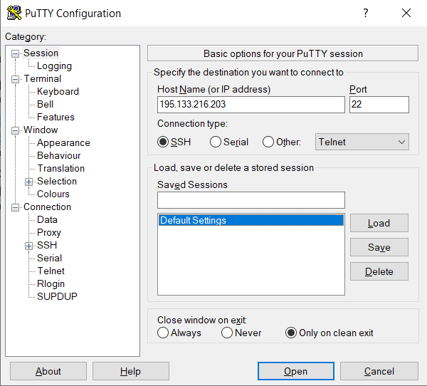

And enter your login and password:

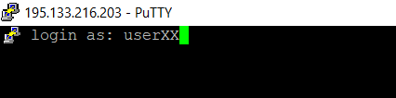

Where XX being the number sent to you in two-digit format, e.g. number three
corresponds to user03.

- To upload files from your computer to the cluster and save files from the cluster to your computer, you can use WinSCP program with the same host name, login and password:

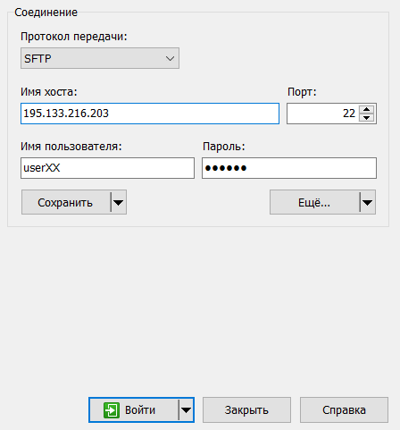

- To connect to the Oleg supercomputer using Linux OS via terminal:
1. shh to your account:
$ ssh userXX@195.133.216.203

Where XX being the number sent to you in two-digit format, e.g. number three
corresponds to user03.
And enter your password.

- To upload files from your computer to the cluster and save files from the cluster to your computer, you can use rsync tool:

Note: When use rsync you should not be connected to the cluster via ssh.

For example, to transfer files to the cluster:
$ rsync [options] source userXX@195.133.216.203:[destination]

In the above example, the [destination] is optional, as when left out SCP will simply copy the source into the user’s home directory. Also, the source should be the absolute path of the file/directory being copied or the command should be executed in the directory containing the source file/directory.

Or to transfer files from the cluster to your computer:

$ rsync [options] userXX@195.133.216.203:[source] destination

- Most popular commands:

$ mkdir dir1 – to make a directory dir1
$ cd dir1 – move to the directory dir1
$ cp file dir1 – copy file1 to the directory dir1
$ cp -r dir1 dir2 – copy directory dir1 to the directory dir2
$ rm file1 – remove file1
$ rm -r dir1 – remove directory dir1
$ module load module1 – load module, i.e. python or uspex
$ module list – check which modules are loaded
$ module avail – check which modules are available
$ module purge – unload all modules
$ bash scr.sh – run script scr.sh
$ sbatch pbs.sh – queue a task pbs.sh

- On Oleg cluster we use Slurm task Manager (https://slurm.schedmd.com/sbatch.html). The basic header or the run script is:
#!/bin/sh
#SBATCH -p lenovo
#SBATCH -J JobName
#SBATCH -t 48:00:00
#SBATCH -N 1
#SBATCH -n 16

and to run your script you have to print the following command:

$ sbatch jobname.sh

